ECE4179/5179 — Assignment Report Template
Due: XX/10/2026, 11:55 PM
Student name | << insert student name >>
Student ID | << insert student ID >>
Student email | << insert student email >>

This is a report template for the ECE4179/5179/6179 Assignment. Fill in every placeholder marked << like this >> and delete it once you have entered your answer. Keep all headings so that any table of contents resolves correctly. Submit this document as a PDF (not .docx); include your name and student ID in the filename.
Submission checklist
☐ Submit as a single ZIP file containing: the PDF of this report, all .ipynb notebooks, and any other required deliverables.
☐ Include your name and student ID in the filename of the ZIP, PDF, and notebooks.
☐ Do NOT submit .doc or .docx files — convert to PDF before submitting.
☐ All results, plots, tables, code screenshots, and discussion must appear in this report.
☐ Declare any use of GenAI in the relevant section of each task.

Questions Attempted
Update the "Attempted?" column as you complete each question.
Question | Topic | Marks | Marking | Attempted? (Y/N)
Q1-1 | MLP forward pass & SGD update | 10 | Report | Did not attempt
Q1-2 | Stacked activation function analysis | 5 | Report | Did not attempt
Q2-3 | Iterative weighted linear regression | 10 | Report | Did not attempt
Q3-4 | Face landmark detection – linear probing | 15 | Report | Did not attempt
Q3-5 | Face landmark detection – model improvement | 10 | Report | Did not attempt
Q4-6 | CNN for traffic sign classification | 15 | Report | Did not attempt
Q4-7 | Occlusion sensitivity analysis | 10 | Report | Did not attempt
Q5-8 | Speech command recognition | 25 | Report | Did not attempt
Total |  |  | 100 | All from report

Question 1 — MLP Analysis (No GenAI)
Note on Generative AI: For Q1-1 and Q1-2 you must work independently. You may not use GenAI tools at all, including for verifying your solutions.

Q1-1. MLP Forward Pass & SGD (10 marks)
Show your working clearly. Unsupported answers may lose marks.
(a) (2 pts) Compute the output of the network for x = (1, 2)ᵀ.

<< Working and final answer for part (a) >>

(b) (1 pt) With label y = 0, compute the binary cross-entropy (BCE) loss for (x, y).

<< Working and final answer for part (b) >>

(c) (1 pt) With label y = 1, compute the BCE loss for (x, y). State whether it is larger or smaller than part (b) and why.

<< Working and final answer for part (c) >>

(d) (2 pts) Let lr = 0.1. For x = (2, -1)ᵀ and y = 0, update w₃,₆ with one SGD step.

<< Working and final answer for part (d) >>

(e) (3 pts) Under the same settings, update w_{1,5}

<< Working and final answer for part (e) >>

(f) (1 pts) Under the same settings, update w_{2,4}

<< Working and final answer for part (e) >>

Q1-2. Stacked Activation Function Analysis (5 marks)
Discuss the behaviour of z₁₀₀₀(x) for x ∈ ℝ, where z₁₀₀₀ is the given activation function composed 1000 times. Support your discussion with clear mathematical reasoning.

(a) (2 pts) Find all fixed points of z, that is, all x ∈ R satisfying z(x) = x. You may argue from Figure 2.

<< Working and final answer for part (a) >>

(b) (3 pts) Determine the response of z1000 to x ∈ R. Justify your answer.

<< Working and final answer for part (b) >>

Question 2 — Iterative Weighted Linear Regression

Q2-3. Iterative Weighted Linear Regression (10 marks)
Report your implementation results below. Include all required plots and numerical results. Your discussion should reflect on the behaviour of the algorithm and the effect of the hyperparameter σ.
Numerical results
Hyperparameter σ used | 55
Final training MSE | 0.12454046876928337
Final validation MSE | 0.0004196998501118245
Number of iterations to converge | 5
Best validation MSE | 0.0004196998501118245
Iteration of best MSE | 39

Training and validation error curves with clear axis labels:
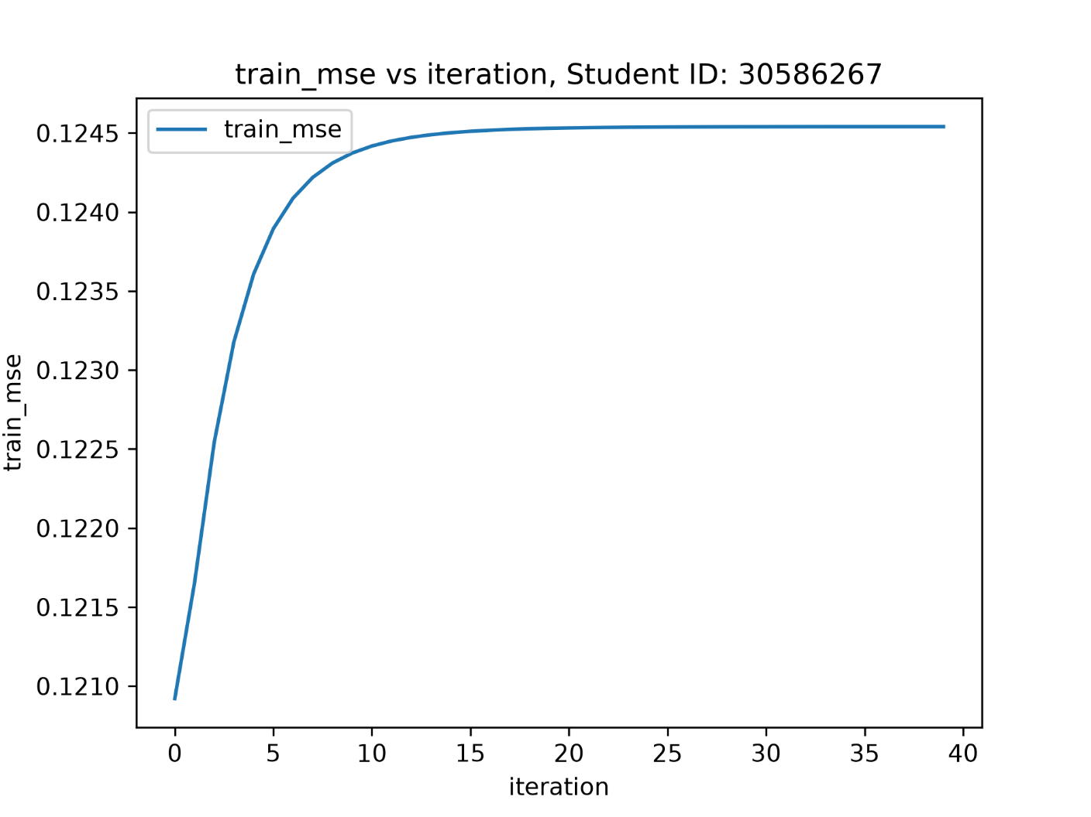
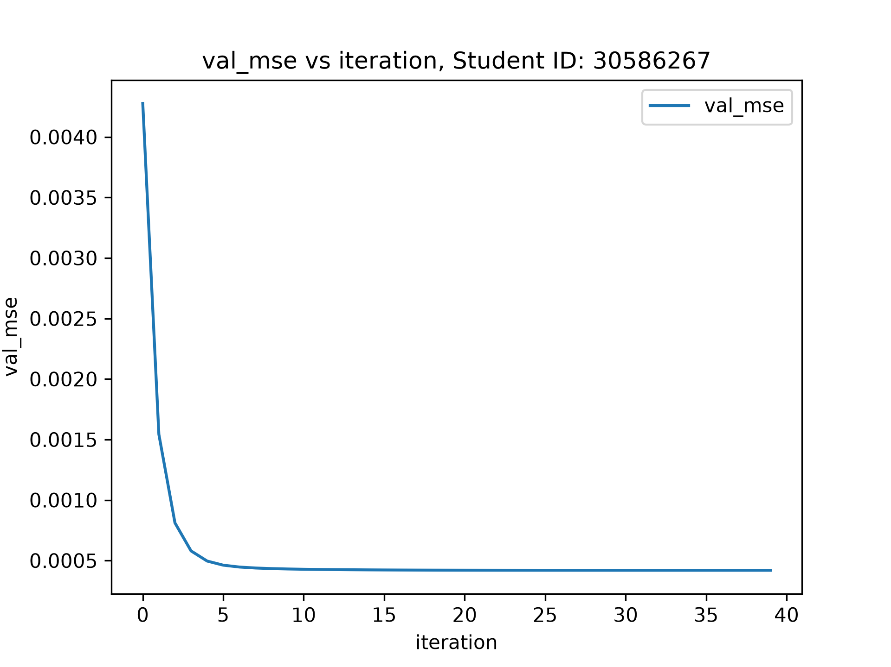

Discussion
<< Discuss the effect of σ, convergence behaviour, and any interesting observations >>
Hyperparameter σ is essentially the learning rate of the alpha weighting matrix. A higher σ value corresponds to an alpha matrix with smaller magnitudes, which translate to more aggressive attenuation of the X samples.
The fact that α_{i} is inversely proportional to residual of y_{i} means a larger residual results in the corresponding X_{i} sample being more aggressively attenuated when computing the closed form solution of w. This effectively captures outliers and decreases their influence in the fit.
Unweighted degree sweeping revealed that polynomial with degree 9 has the best starting val_mse.
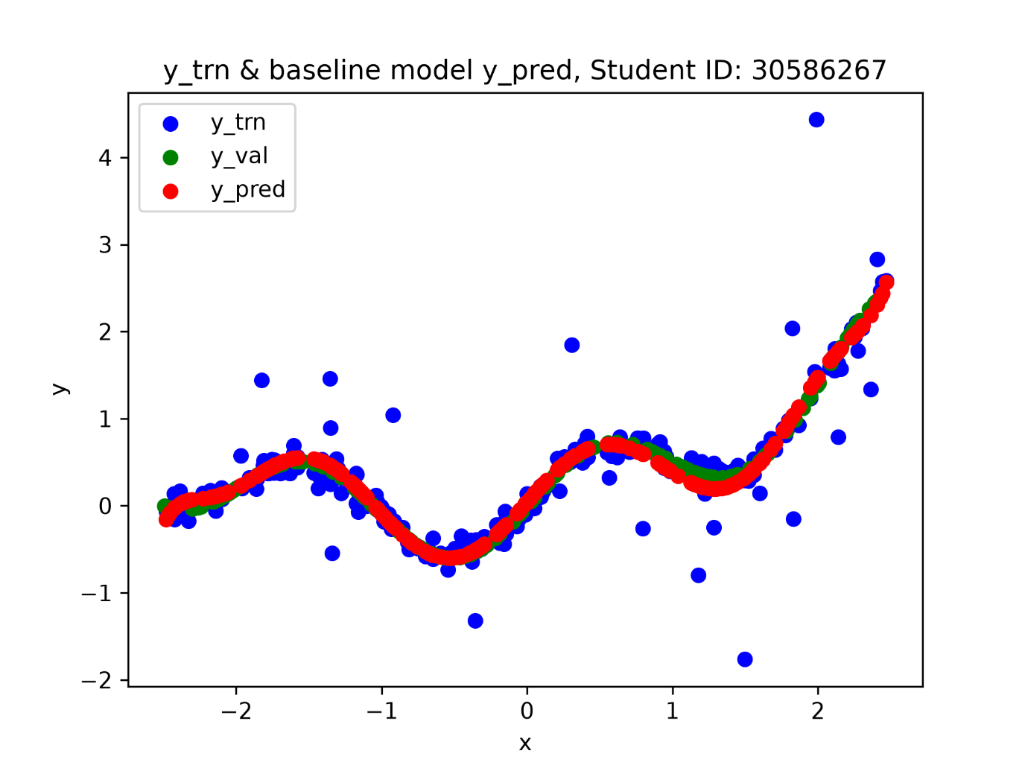
The baseline model has a val_mse of 0.004277185261129884
The outliers negatively impact the accuracy of the fit by pulling it away from the y_val values.
Sweep of σ value using polynomial degree 9 revealed that the optimal σ value is 55:
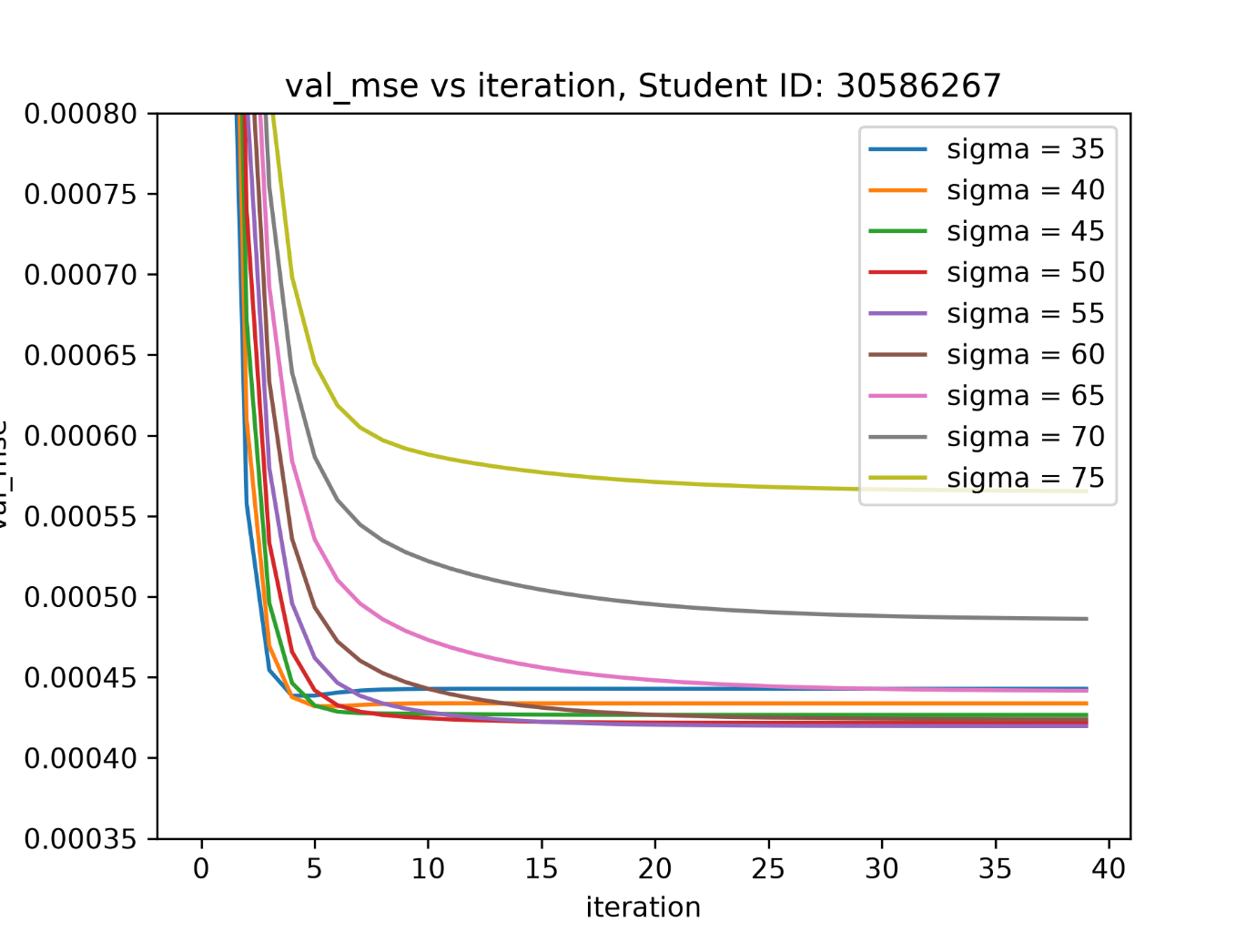
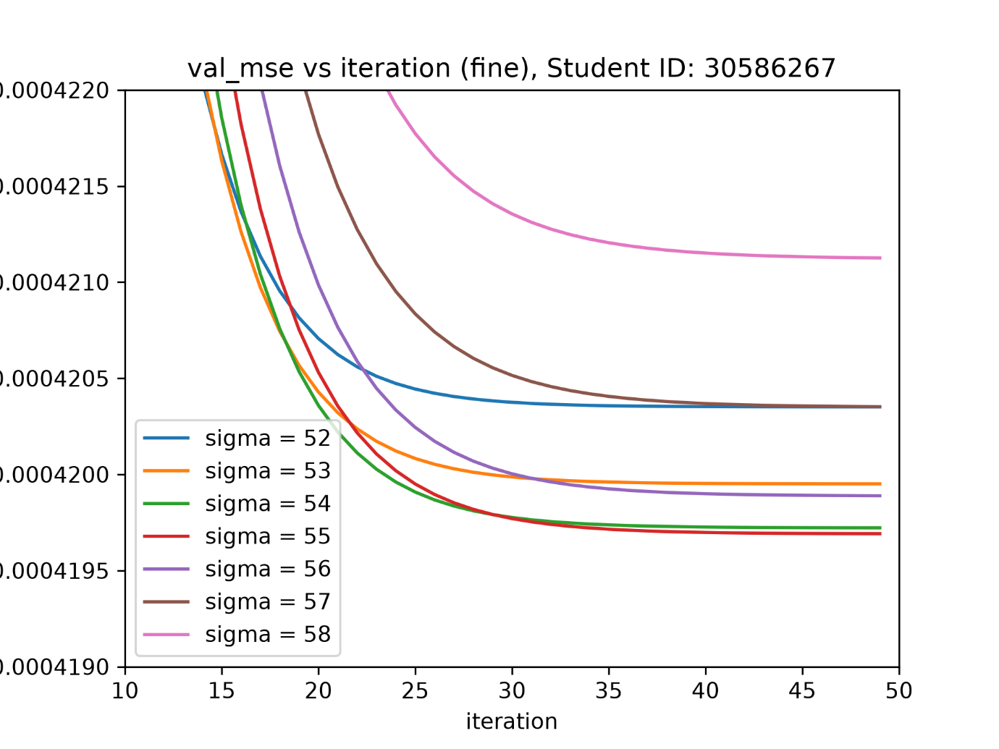
Using these optimal values to run the IWSL function again produces this comparison:
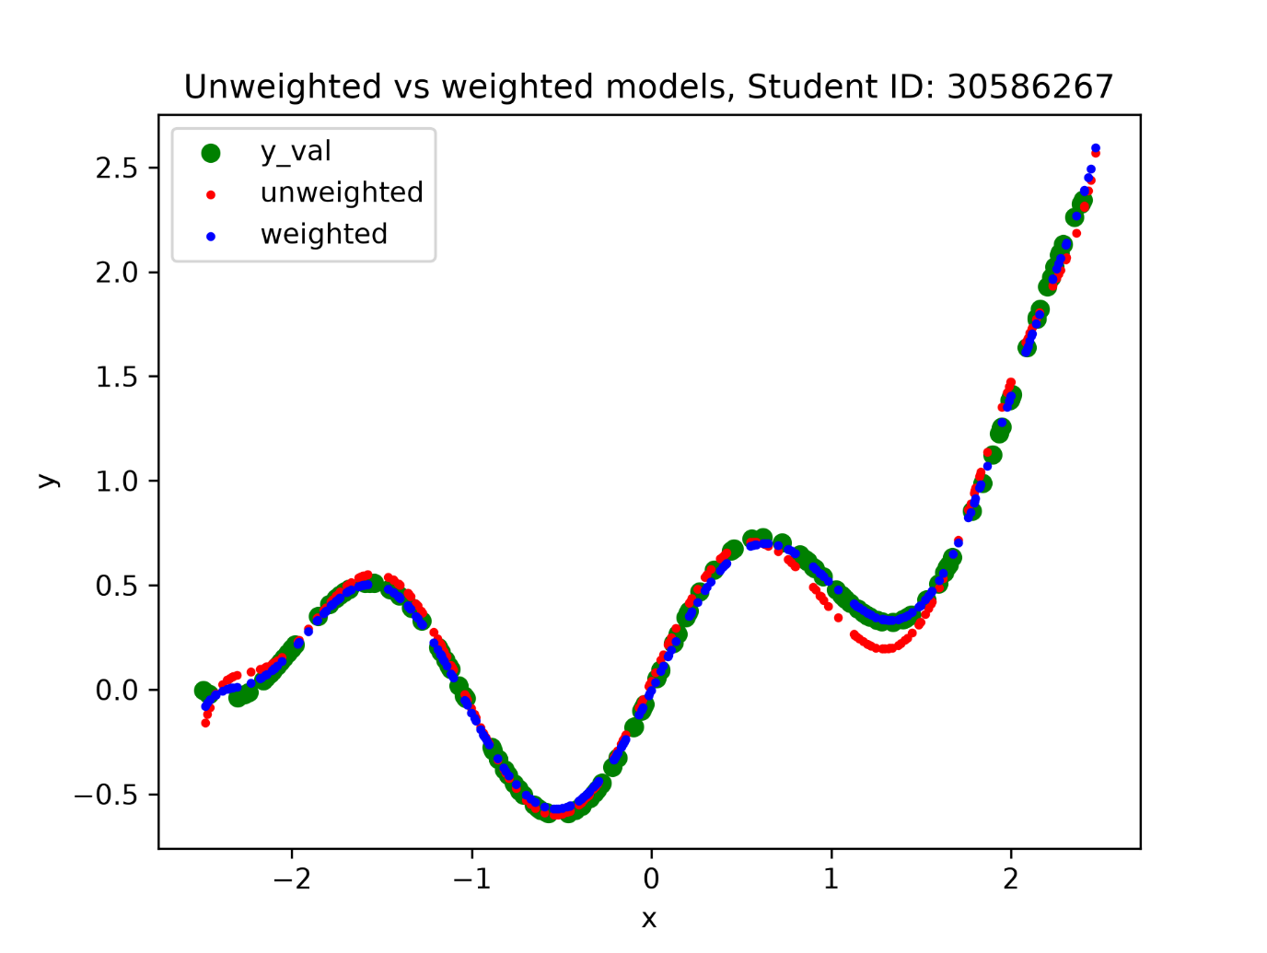
The weighted version more closely matches the evaluation set.
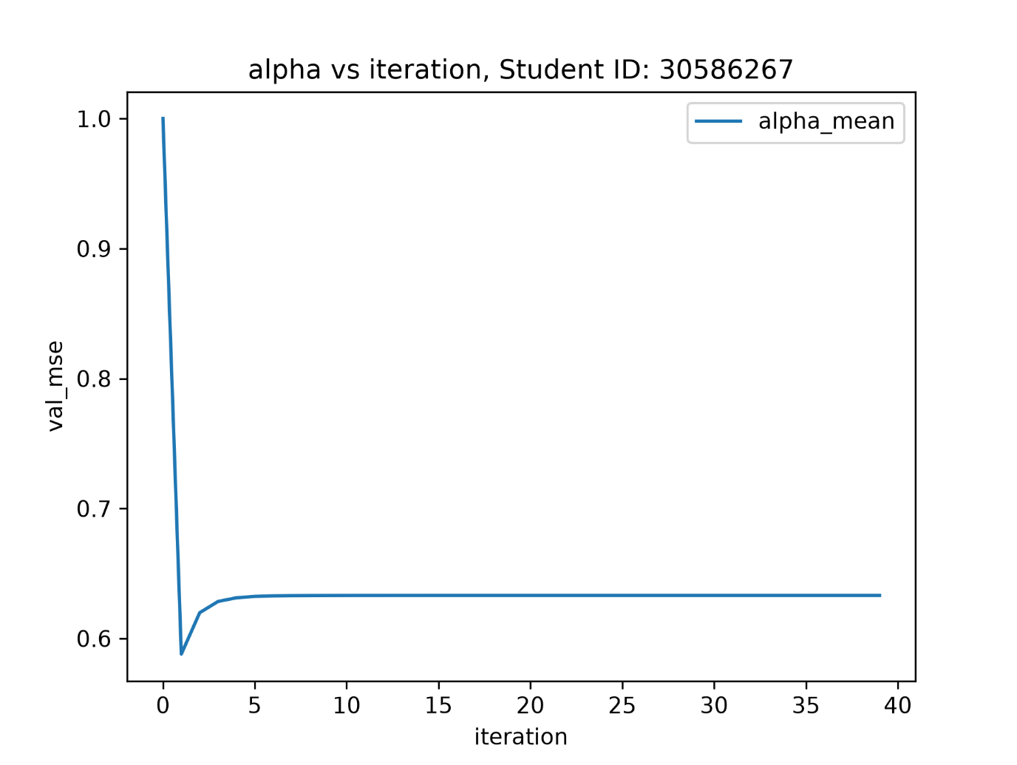
The model essentially converged when the mean alpha value stopped changing at around 5 iterations.

GenAI Declaration
Did you use any GenAI tools for this question? No

If yes, state: (i) what you asked, (ii) which suggestions you tried, and (iii) what worked or was discarded.

N/A

Question 3 — Face Landmark Detection

Q3-4. Baseline: Linear Probing (15 marks)
Report the results of your linear probing experiment below. A well-trained linear probe should achieve a validation RMSE of approximately 12 pixels.
RMSE results
Validation RMSE (pixels) | << value >>
Test RMSE (pixels) | << value >>

Training and validation loss curves with clear axis labels:
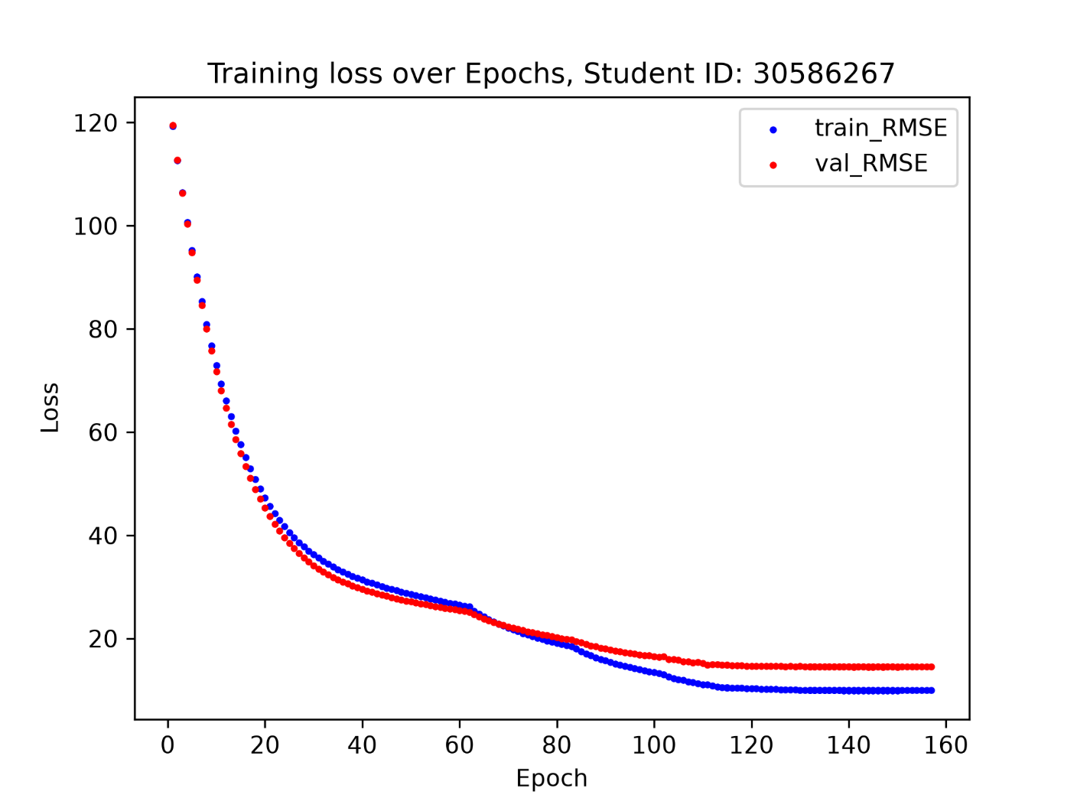

5 Example Predictions on Validation and 5 on Test Images:
[ Paste predicted vs. ground-truth landmark visualisations here ]

Discussion
<< Brief discussion of your results >>

GenAI Declaration
Did you use any GenAI tools for this question? << Yes / No >>

If yes, state: (i) what you asked, (ii) which suggestions you tried, and (iii) what worked or was discarded.

<< GenAI usage description, or "N/A" >>

Q3-5. Model Improvement (10 marks)
Document the improvements you made to the baseline model. Boss performance target: ~7 pixels RMSE on the validation set.
RMSE results
Validation RMSE (pixels) | << value >>
Test RMSE (pixels) | << value >>

15-4-1 unfroze feature layer 8
15-4-2 unfroze feature layer 7
15-4-3 unfroze feature layer 6

Training and validation loss curves with clear axis labels:
[ Paste your improved model loss curves here ]

5 Example predictions on test images:
[ Paste test image prediction visualisations here ]

Reflection: modifications made and their effect
<< Describe what you changed, why, and the performance impact >>

GenAI Declaration
Did you use any GenAI tools for this question? << Yes / No >>

If yes, state: (i) what you asked, (ii) which suggestions you tried, and (iii) what worked or was discarded.

<< GenAI usage description, or "N/A" >>

Question 4 — Classifying Traffic Signs with CNNs

Q4-6. CNN Training (15 marks)
Train a CNN on GTSRB from scratch (no pretrained models). Your model must achieve at least 90% test accuracy to be considered competent.
Architecture summary
<< Describe your CNN architecture (number of conv blocks, kernel sizes, pooling, FC layers, etc.) >>

Training details
Optimiser | << value >>
Learning rate | << value >>
Batch size | << value >>
Number of epochs | << value >>
Data augmentation, i.e. transformations | << value >>

Accuracy results
Validation accuracy (%) | << value >>
Test accuracy (%) | << value >>

Training and validation accuracy / loss curves with clear axis labels:
[ Paste your training curves here ]

Discussion
<< Discuss your design choices, challenges, and results >>

GenAI Declaration
Did you use any GenAI tools for this question? << Yes / No >>

If yes, state: (i) what you asked, (ii) which suggestions you tried, and (iii) what worked or was discarded.

<< GenAI usage description, or "N/A" >>

Q4-7. Occlusion Sensitivity Analysis (10 marks)
Generate occlusion heatmaps for three correctly classified and three misclassified test images. Discuss what the model appears to focus on.
3 Heatmaps with original images — correctly classified images
[ Paste occlusion heatmaps for 3 correctly classified images here ]

3 Heatmaps with original images — misclassified images
[ Paste occlusion heatmaps for 3 misclassified images here ]

Discussion
<< Discuss what the heatmaps reveal about the model's focus and any patterns in misclassifications >>

GenAI Declaration
Did you use any GenAI tools for this question? << Yes / No >>

If yes, state: (i) what you asked, (ii) which suggestions you tried, and (iii) what worked or was discarded.

<< GenAI usage description, or "N/A" >>

Question 5 — Speech Command Recognition

Q5-8. Speech Command Recognition (25 marks)
Build a model to classify ten spoken commands. Submit your final test predictions to the Kaggle competition (linked on Moodle) and report your Kaggle username.
Approach Discussion (Detailed Discussion of the Model Architecture and Improvements Made):<< Describe your feature extraction approach (e.g. Wav2Vec2, Whisper) and classifier >>

Training details
Feature extractor model | << value >>
Frozen / fine-tuned layers | << value >>
Classifier architecture | << value >>
Optimiser & learning rate | << value >>
Epochs / early stopping | << value >>

Results
Validation accuracy (%) | << value >>
Kaggle username | << value >>
Kaggle test accuracy (%) | << value >>

Training curves with clear axis labels:
[ Paste your training and validation accuracy / loss curves here ]

GenAI Declaration
Did you use any GenAI tools for this question? << Yes / No >>

If yes, state: (i) what you asked, (ii) which suggestions you tried, and (iii) what worked or was discarded.

<< GenAI usage description, or "N/A" >>

Acknowledgements (optional)
<< List any people or resources you found particularly helpful (not required) >>

